**PMAS - Arid Agriculture University Rawalpindi**

Name: ____________________

Roll No: ___________________

**Quiz No. 6**

**University Institute of Information Technology**

**Class/Section___**

**BS (IT)-VII (M/E) : Visual Programming(CS-693) Maximum Marks: 15.**

**Question 1. Write down appropriated Code and description for the following XML Diagram.**

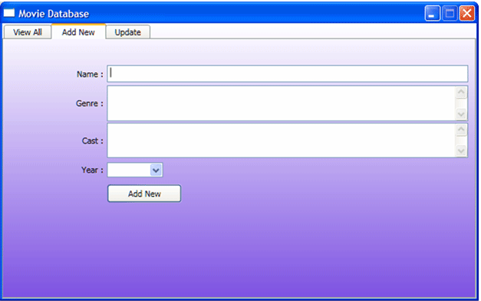

**Question 2. For a given diagram, write appropriated ode for search record in XML. Assume that file is already attached.**

